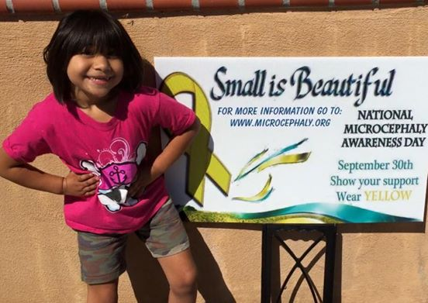



Scarlett Rose

(5 yrs.old)

Homeschooled

Diagnosed with Microcephaly

at birth.

Wear Yellow on Microcephaly Day...September 30th

What is Microcephaly? Microcephaly means small (micro) head (cephaly). It is a neurological disorder where the head circumference is less than it should normally be in an infant or a child. The condition can be present at birth or develop within the first few years of life.  Most parents do not know why their child has Microcephaly & may never know the cause - even with advanced genetic testing. The most difficult thing that we have found is each and every case of Microcephaly is different.  Some children have mild to moderate delays, while others have severe delays.  Most of the time there is no way to know how your child diagnosed with Microcephaly will develop.  In some cases delays are apparent right away, and in others delays won't show up until after a year old. Microcephaly affects more than 25,000 in the United States each year. Microcephaly does NOT get recognition it deserves, many doctors are not well educated about Microcephaly! We need your support: Join us to raise awareness for Microcephaly.