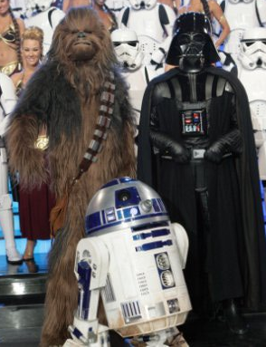
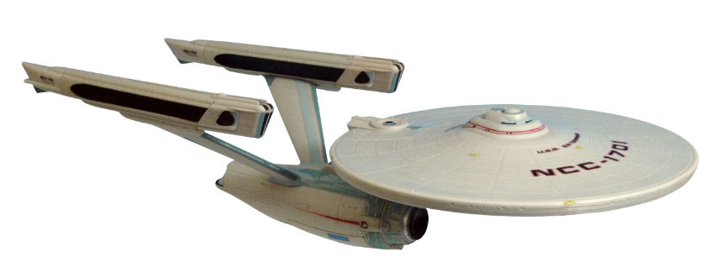
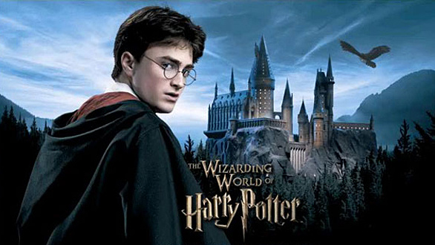
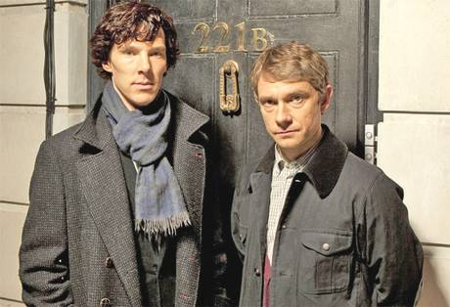
COMIC-CONcert!

Can’t wait for Comic-Con?
Want to show off your costume and see “real” Stormtoopers?
Channel your inner Zombie/Tinkerbell/Darth Vader/Spiderman
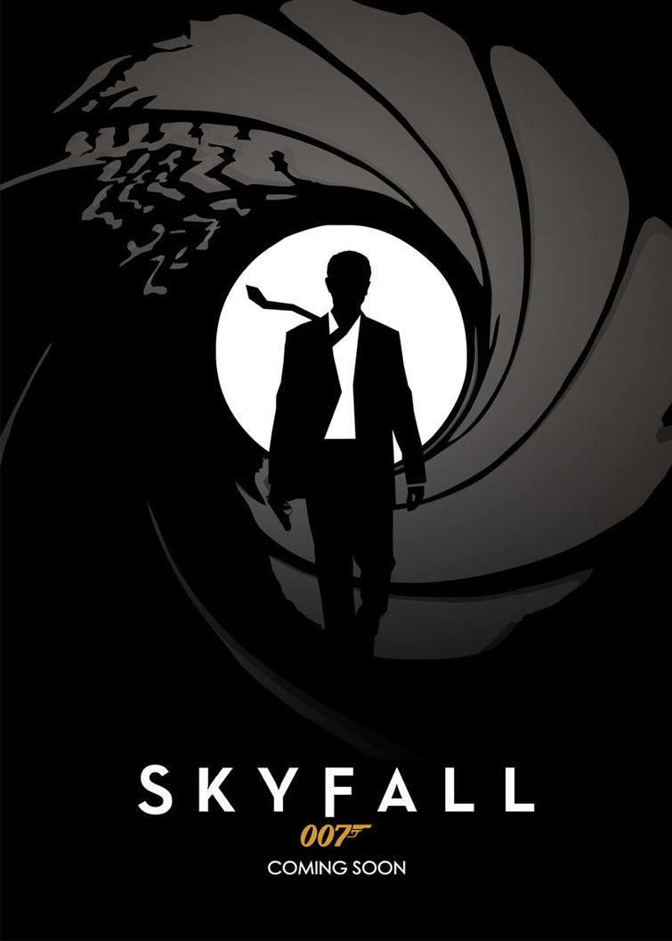
and join the party at Scripps Ranch High School!

Friday, June 6th, 2014
Gates and food trucks open at 4 PM; music performances begin at 5 PM.
SRHS, 10410 Treena Street, San Diego, CA 92131
Tickets: $10 at the door

Watch the award-winning band, orchestra, choir and percussion sections of Scripps Ranch High perform in costume to theme music from your favorite movies and shows: Superman, Star Wars, Dr. Who, Lord of the Rings, Harry Potter, Sherlock Holmes, Game of Thrones, Avengers and more.
SPECIAL APPEARANCE BY 501ST LEGION “bad guys” & REBEL LEGION “good guys” OF STAR WARS!

Get creative and come as your favorite character!
(Fantasy costume “weapons” are OK, but please leave your realistic guns and knives at home.)

Enjoy the live entertainment from the award-winning SRHS musicians while you feast on dinner at this fundraiser to benefit the SRHS music programs. It’s open festival seating, so bring your low beach chairs and blankets.
For more information, visit our facebook page at www.facebook.com/SRHSComicConcert2014.
