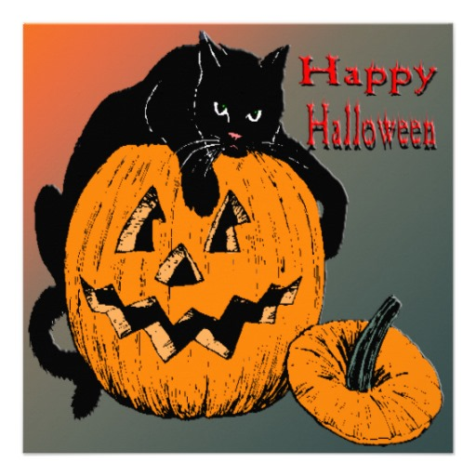

Multipurpose Room

## Math Games! Food for Sale! Raffles! Wear your Costumes!

## Come out for some spooky math fun with your IA Family!

Monday, October 21st from 5:30 – 7:30 pm

Join us for a night of spooky math fun!

Spooky Family

Math Night

# Nam lobortis felis sed est commodo posuere.